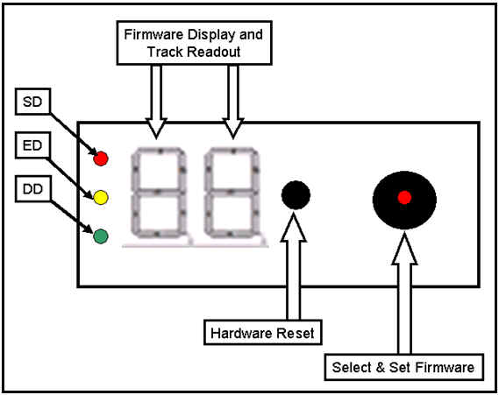
SD = Single Density Red LED Active
ED = Enhanced Density Yellow LED Active
DD = Double Density Green LED Active
Hardware Reset = Take the Mega Speedy out of Firmware Mode into a 3 second Change or the Mega Speedy will Auto Select E1.
Select & Set = Is a Rotary Select Switch with Push Button to Select Firmware!
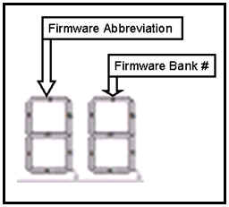
Different Modes the Mega Speedy Can Operate As
- "E" Mega Speedy
- "S" Super Speedy
- "y" Speedy
- "o" original 1050
- "t" 1050 Turbo
- "H" Happy
- "U" US Doubler
- "A" Super Archiver
- "d" 1050 Duplicator
- "u" SuperMax
- "FL" Program your FLASH Rom

